Working with MongoDB on AWS

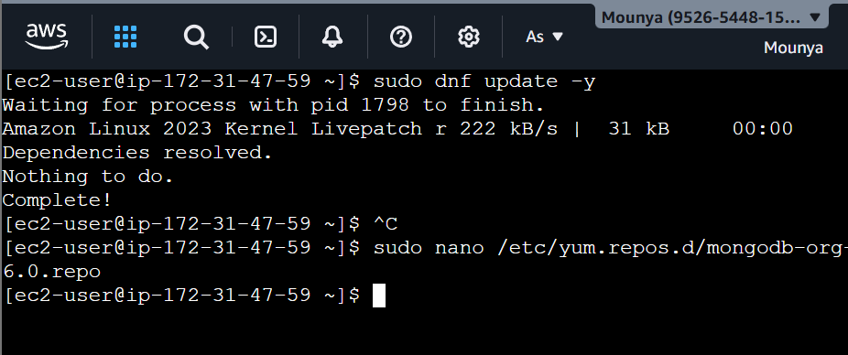

Next write the below code into the nano file and save and exit:
[mongodb-org-6.0]
name=MongoDB Repository
baseurl=https://repo.mongodb.org/yum/amazon/2023/mongodb-org/6.0/x86_64/
gpgcheck=1
enabled=1
gpgkey=https://www.mongodb.org/static/pgp/server-6.0.asc

INSTALL MONGODB

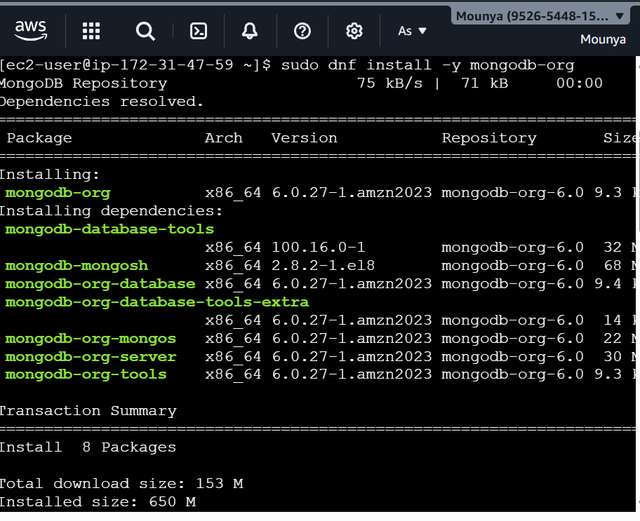

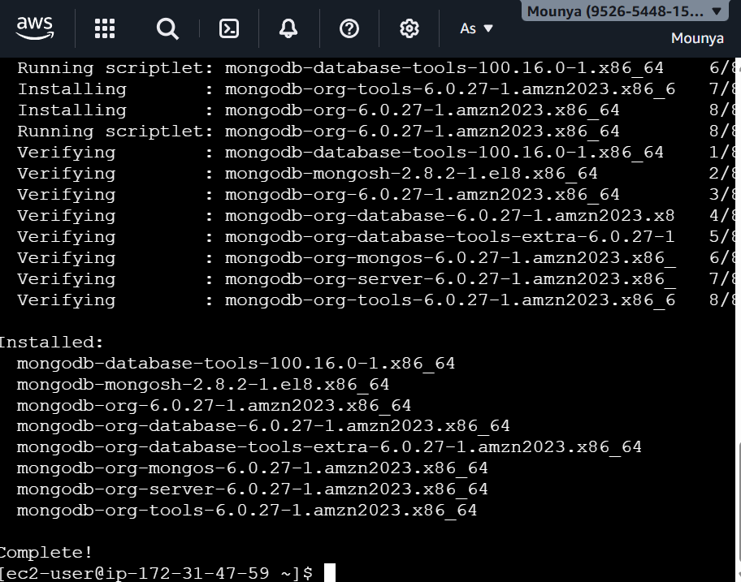

START MONGODB SERVICE
ENABLE AUTO-START
CHECK STATUS
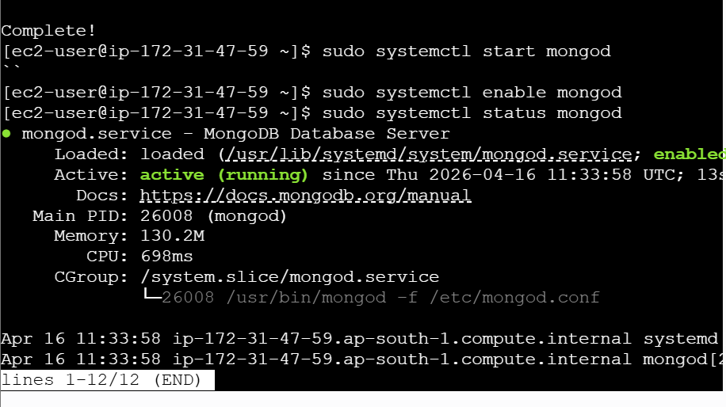

CONNECT TO MONGO SHELL
BASIC MONGODB COMMANDS

